7
Planetary Data System
Proposer's Archiving Guide (PAG)

December 15, 2015

Version 2.12

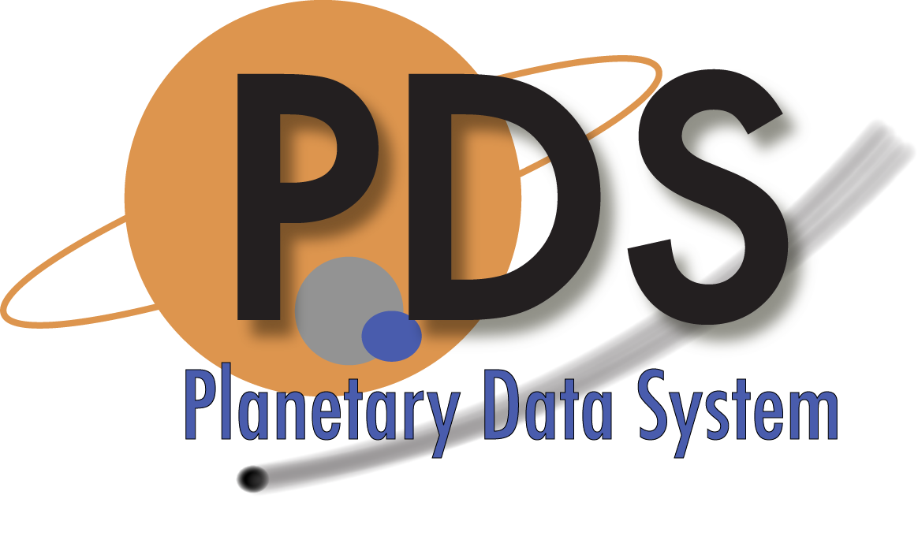

CHANGE LOG

Revision |  | Date |  | Description |  | Author
Start Draft | April 2, 2003 |  | Initial outline |  | R. Joyner
Version 2.0 | 2014-05-1 |  | Updated to comply with PDS4 |  | R.Joyner

Version 2.10 |  | Date |  | Description |  | Author
Section 8 | 2015-10-19 |  | Removed costing section pending rewrite that is valid for PDS4 (MC AI 2015-09-28/01) |  | Simpson
1.2  6.2  Appendix B | 2015-10-19 |  | Removed references to costing section and web page with costing procedure |  | Simpson
1.2 | 2015-10-19 |  | Corrected reference to Appendix C (now to B) |  | Simpson
1.4 | 2015-10-19 |  | Updated list of applicable documents |  | Simpson
2.0  3.5.2  3.5.4  6.5.1  7.0  7.5  Appendix A | 2015-10-19 |  | Minor grammatical, wording, font, and pagination corrections and improvements |  | Simpson
4.1.2 | 2015-10-19 |  | Noted upcoming node name changes at Rings and Imaging |  | Simpson
7.5 | 2015-10-19 |  | Added sentence noting that EN is the steward for all context products. |  | Simpson
7.7 | 2015-10-19 |  | Removed section heading (there is no content) |  | Simpson
Appendix B | 2015-10-19 |  | Updated references 3 and 4, removed 5 and 7; renumbered remaining references. |  | Simpson
4.1 | 2015-11-27 |  | Changed “Management Office” to “Project Office” and updated names of CIS and RMS nodes to reflect nomenclature as of December 2015. Corrected sentence structure by adding verbs to DN summaries. |  | Simpson
Version 2.1.2 | 2015-12-15 |  | Added information under the umbrella of “band-aid” fixes per MC action items. |  | R.Joyner / R.Simpson

TABLE OF CONTENTS

1.0 Introduction 4
1.1 Purpose 4
1.2 Scope 4
1.3 Audience 4
1.4 Applicable Documents 5
2.0 OVERVIEW OF THE ARCHIVING PROCESS 6
3.0 elements of a good archive 7
3.1 Overview 7
3.2 Instrument Data Products 7
3.3 Other Mission Data 7
3.4 Higher Level Products 8
3.5 Documentation 8
3.5.1 Data Management and Archive Plan (DMAP) 9
3.5.2 Data Product Software Interface Specifications (SISs) 9
3.5.3 Archive Bundle Documentation 9
3.5.4 Calibration Documentation 9
3.5.5 Other Documentation 10
3.6 Archive Organization 10
4.0 THE PLANETARY DATA SYSTEM (PDS) 12
4.1 Roles and Responsibilities (within the PDS) 12
4.1.1 Engineering Node 12
4.1.2 Discipline Nodes 12
4.2 PDS Roles in Mission Archiving 13
5.0 MISSION ARCHIVING ROLES AND ACTIVITIES 14
5.1 Organizing the Archiving Activity 14
5.2 Mission Archiving Roles 14
5.2.1 Principal Investigator (PI) 14
5.2.2 Mission Archive Scientist 15
5.2.3 Archive Preparers 16
6.0 STEPS IN THE ARCHIVE PROCESS 17
6.1 Pre-proposal Briefing 17
6.2 Proposal Phase 17
6.3 Concept Study Report (CSR) 17
6.4 KDP A – Concept Development 18
6.5 KDP B – Mission / PDS MOU through DMAP 18
6.6 KDP C/D – Design, Construction, and Test 18
6.6.1 Sample Data Reviews & End-to-End Testing 19
6.7 KDP E (Operations) 19
6.8 Major Documents and Reviews by KDP 20
7.0 deliverables expected by the pds 22
7.1 Memo of Understanding (MOU) 22
7.2 Data Management and Archiving Plan (DMAP) 22
7.3 Interface Control Document (ICD) 22
7.4 Archive Description Document (ADD) 22
7.5 Context Products 23
7.6 Lien Resolution 23

APPENDIX A ACRONYMS 25
APPENDIX B ONLINE RESOURCES / REFERENCES 26

Introduction

Purpose

The purpose of this document is to provide basic information about archiving science data in the Planetary Data System (PDS). This document also provides information about the archive process (including PDS expectations) to scientists proposing for NASA planetary programsError: Reference source not found. The PDS hopes that better understanding of archiving at the earliest stage will help proposers address key issues, integrate archiving with the data production pipeline, and allocate adequate resources for archiving. The result should be higher quality archives produced more efficiently at lower overall cost.

Scope

This document addresses the following topics broadly, but with enough detail that scientists should be able to draft the archiving section of a planetary proposal. A generic 'mission' context is assumed since the majority of data (both in volume and complexity) flows from NASA missions.

- Overview of the archiving process, including goals
- Elements of a good archive
- Organization and structure of the Planetary Data System
- Mission archiving roles and activities
- Steps in the archive process

- Typical deliverables

Appendix B provides links to additional resources and sample documents.

Audience

This document is written primarily for scientists responding to NRAs and AOs for NASA planetary missions. Others (such as proposers for individual instruments, proposers to data analysis programs, and foreign investigators seeking to archive with PDS) should find the material useful, after appropriate adjustments. The expected audience for this document includes:

- Proposers to NASA mission-scale opportunities
- Proposers for investigations to supply instruments on NASA missions

- NASA managers at various levels
- Archivists and data management professionals

Applicable Documents

[1] Planetary Data System Standards Reference, 22 September 2015, Version 1.4.0

[2] PDS4 Data Dictionary - Abridged, 26 September 2015, Version 1.5.0.0

[3] PDS4 Concepts, 3 September 2015, Version 1.4.0

[4] PDS4 Policy on Data Processing Levels (2013-03-01); amended by PDS MC

OVERVIEW OF THE ARCHIVING PROCESS

The PDS archives and distributes documented data to the planetary science community. It was established in response to requests for increased availability of planetary data and to concerns that data from past NASA missions were degrading to the point of becoming unusable for analysis. PDS functions include both ingestion and distribution of data at 'nodes' specializing in certain scientific disciplines and/or technical skills. A registry provides high-level information on node holdings.

To fulfill its charter, the PDS requires that data it handles be understandable, be in formats that future scientists will find easy to use, and follow standards for organization and content that facilitate machine-assisted correlative science across missions and science disciplines. The PDS requires that submitted data meet published standards regarding format, content, and documentation [1, 2, 3, 4]. A range of formats has been defined, but 'tables' and 'images' account for the majority of products. Data products are organized logically into 'collections’ of data, which are further organized into 'bundles’ of collections.

At an early stage mission and instrument personnel should define the data products they intend to archive, estimate their volume and generation rate, and negotiate a preliminary delivery procedure with the PDS. Adequate documentation for both understanding and using the data is critical to each archive; mission planners should be mindful of the archive documentation requirement as they develop explanatory materials for other purposes. All archive submissions to the PDS are peer reviewed by scientists and data engineers to ensure that PDS standards have been met and that the archive is complete and the data are useful. This usually occurs at several stages for mission archiving.

Once data are fully integrated into the PDS, they may be retrieved through electronic queries over the Internet, or by special request on physical media. The PDS provides copies of all accepted data to the NASA Space Science Data Coordinated Archive (NSSDCA)., which serves as both the 'deep archive' for PDS and the official distribution point for requests originating outside the planetary research community.

elements of a good archive

Overview

A useful mission archive, as required by most NRAs and AOs, includes raw data formatted from each instrument, data calibrated in physical units, and derived products based on further processing of the data and/or combinations of different data such as maps, overlays, and comparative tables. The archive contains sufficient documentation of the mission, the instruments, and the calibrations that a scientist of a future generation could make use of the data and, if appropriate, even recalibrate the data. The archive includes complete information about the geometry relevant to the mission (e.g., spacecraft position and orientation relative to the target). It includes meta-data to help in searching / retrieving the data in the PDS registry, supporting documentation, and other information relevant to understanding or interpreting the data. Finally, the archive uses a straightforward organization and a small number of widely recognized, non-proprietary formats.

An archive designed in advance and fed by a data processing pipeline contains 'standard' products, usually from a single instrument, but possibly from an integrated suite of instruments. As the mission evolves, new 'special' products (combinations of data from multiple sources, the results of analyses not originally planned, etc.) may be defined. The PDS encourages inclusion of these additional special products in the archive; however, the decision to do so rests with the mission (or instrument) and often depends on availability of resources.

Instrument Data Products

Missions are normally expected to archive both raw data (formatted appropriately for each instrument) and data fully calibrated in physical units. Where no investigation team has been selected (e.g. for radio science), the mission should still consider archiving the data from all major subsystem operations if there is potential for any scientific use.

The archive should include a complete description of the operation of each instrument and of the calibration procedure and all files needed to carry out the calibration. Formats of the data, both raw and calibrated [4], should be simple, non-proprietary, and widely used—formats that would be familiar to most in the relevant segment of the research community. Each product has a label, a detached label in a separate file, which describes the data in a structured XML format. This label is intended to be read by humans and by data analysis software.

Other Mission Data

The mission is expected to archive complete geometric details from launch through end of mission. These typically include the full ephemeris of the spacecraft and orientation of the spacecraft and all instruments, the relationship of these to coordinate systems on the target, a history of all significant spacecraft events, and other housekeeping data (such as temperatures and power levels) that might be useful in understanding the behavior of instruments.

The mission should also archive ancillary data that are important to either mission planning or interpretation of the data from the mission. These might include contemporaneous, Earth-based observations or key models, such as shape models, used in interpreting the data.

Normally, radiometric tracking data should be archived even if there is no "instrument team" for radio science.

The mission normally provides “context” products describing the overall mission, the spacecraft, and the instrument(s) so that future scientists will be able to make use of the data.

Higher Level Products

AOs and NRAs may also require, and the PDS encourages, the mission to archive higher-level products. These might include derived [4] products such as mosaics, maps, data resampled to a common interval, fits to model results, or inversions. Higher-level products may come from a single instrument or from combining the results from several instruments.

Documentation

Second in importance only to the data products themselves is the documentation that accompanies them in the archive. The documentation takes several forms — labels, context information, and stand-alone documents — each of which is described briefly below.

- Labels

Every product in the archive must be described by an associated label. Every label is detached from the file or files it describes. Labels are expressed in XML format because it is an industry standard for which many software tools exist, and because the label can be readable by humans as well as by data analysis software.

- Context Information

The mission team, working with the lead node, is usually responsible for drafting and maintaining descriptions of the spacecraft and the mission itself, along with a list of references. Each instrument team, working with the lead node, drafts and maintains descriptions of its instrument (the instrument, its modes, and the scientific objectives of the investigation) and its data (including coverage and quality). These descriptions are referenced in each archive. They are also ingested into the PDS registry to be available for searching.

- General Documentation

The remaining documentation provides the user with a complete description of the format and content of the archive. It can often be assembled from source material developed for other purposes — interface descriptions, calibration reports, journal submissions and other publications, etc. For present purposes this additional documentation will be called the Archive Description Documentation (ADD) though it is neither necessary nor expected that a physical ADD will be created. See Section 7.4 Archive Description Document (ADD) for additional information.

Note that the names and definitions of the component documents mentioned below may vary among missions and agencies.

Data Management and Archive Plan (DMAP)

The DMAP is generally produced by the project / mission, as a requirement of the mission, and describes the overall product archiving plan and roles. In the definition stage of archive production, each instrument team and a PDS representative must come to an agreement that defines the archiving tasks that each party will perform, along with a schedule. This agreement is often documented in the Data Management and Archive Plan (DMAP), signed by the instrument PI, the node manager, the mission project manager and the PDS program manager. The DMAP is a "living" document in the sense that it must be revised — often frequently at the beginning of a mission — to reflect changes in the data flow and schedule. Since the DMAP is concerned more with production of the archive than its content, its inclusion in the ADD is optional.

Data Product Software Interface Specifications (SISs)

During the next stage, each instrument team will produce a Software Interface Specification (SIS) for each type of data product. A SIS describes the product format (at the bit level if necessary) and content in sufficient detail for a scientist to use the products. PDS does not require that a separate data product SIS be included with the archive if the product labels contain equivalent information; however, many missions require both. If included, each SIS should be considered a separate chapter in the ADD.

Archive Bundle Documentation

It is common to document the structure and content of an archive in an Archive Bundle SIS, which describes the organization of directories and files of the archive bundle and associated collections which, if required, will be delivered to the PDS.

Calibration Documentation

Each instrument team should include a description of the calibration procedure (or algorithms) and all necessary data files so that future users can reproduce the calibration. The calibration description should be appropriate to the processing level [4] of the data in the archive. Keep in mind that pre-flight data may be needed to describe the calibration process accurately. Sometimes it is useful to include computer source code as documentation. However, providing source code alone, expecting future scientists to use it, is not considered an acceptable response to the calibration documentation requirement because software is almost always platform dependent and no software can be guaranteed stable over extended periods of time regardless of the platform.

Other Documentation

Additional documentation such as journal submissions and other publications describing the instrument and investigation, technical reports, analysis algorithms, operations plans, and other material may also be included in the archive with due regard to copyright constraints. An explanation of processing steps should be included for higher-level products so that scientists in the future can understand how those products were generated. PDS has adopted the PDF/A standard as the archival format for complex documents. UTF-8 encoded text files may be used for simple documents that do not require graphics or special formatting control.

Archive Organization

As noted above, data products are organized logically into bundles and associated collections of data. Mission data are usually delivered incrementally to the PDS every 3-6 months—sometimes negotiated to be 'electronic' rather than physical delivery. The structure illustrated below is one possibility; details must be negotiated with PDS and, if required, documented, in the Archive Bundle SIS.

The root directory corresponds to the top level of a bundle. It may contain a Product_Bundle and subdirectories corresponding to at least some of its member collections.

root Directory
File or Directory Name | Notes
root | may be unnamed
bundle[_*].xml
readme[_*].[html,txt] | described by bundle[_*].xml
browse[_*]
calibration[_*]
context[_*]
data[_*]
document[_*]
geometry[_*]
miscellaneous[_*]
xml_schema[_*]
spice_kernels[_*]

A bundle is described by a label with the name “bundle[_*].xml”. One or more of these files may be included under the root of the transfer directory structure, but none is required. See the PDS Standards Reference [1] for more information.

THE PLANETARY DATA SYSTEM (PDS)

This section briefly describes the organization of the PDS, some of its responsibilities, and how those are distributed within the system.

Roles and Responsibilities (within the PDS)

The role of the PDS is to ensure that future generations of scientists can make good use of data returned from today's NASA missions. The PDS comprises several operational units or 'nodes.' Each node is staffed and operated independently at a university, government research center, or similar institution and curates data within a discipline of planetary science and/or provides specialized technical expertise to the PDS. The PDS Project Office is located at NASA’s Goddard Space Flight Center (http://pds-mgmt.gsfc.nasa.gov)

Engineering Node

The PDS Engineering Node (EN), located at the Jet Propulsion Laboratory, provides PDS-wide infrastructure, a complete catalog of all data holdings, and a Web interface to PDS holdings (http://pds.nasa.gov). For purposes of this document its most important role is as a source of tools and standards for constructing and validating archives.

Discipline Nodes

Each discipline node (DN) is responsible for data in a specific subject area or specialty; each maintains the PDS data holdings in that specialty. At least one discipline node will work closely with the mission team throughout archive development.

This is a brief summary of the current discipline nodes.

Planetary Atmospheres Node, located at New Mexico State University (Las Cruces, NM), concentrates on planetary atmospheres, including the gas giant planets. (http://atmos.pds.nasa.gov )

Geosciences Node, located at Washington University (St. Louis, MO), specializes in the surfaces and interiors of terrestrial planets. (http://geo.pds.nasa.gov)

Planetary Plasma Interactions Node, located at the University of California, Los Angeles, is concerned with fields and particles, plasmas, and interactions with the interplanetary medium. (http://ppi.pds.nasa.gov)

Ring-Moon Systems Node, located at the SETI Institute (Mountain View, CA), concentrates on planetary ring systems, regular satellites, and their dynamical interactions. (http://rings.pds.nasa.gov)

Small Bodies Node, located at the University of Maryland (College Park, MD), is concerned with comets, asteroids, trans-Neptunian objects (including Pluto), and interplanetary dust. (http://sbn.pds.nasa.gov )

Cartography and Imaging Science Node, located at the U.S. Geological Survey (Flagstaff, AZ) and Jet Propulsion Laboratory (Pasadena, CA), specializes in digital imaging, image processing, and catography. CIS has also accepted responsibility for large icy satellites.
(http://img.pds.nasa.gov)

Navigation and Ancillary Information Facility (NAIF), located at the Jet Propulsion Laboratory (Pasadena, CA), specializes in observational geometry (ephemerides and orientations, including the SPICE information system) and ancillary information (e.g., spacecraft engineering data). (http://naif.pds.nasa.gov)

PDS Roles in Mission Archiving

Early in the mission life cycle, PDS will schedule an orientation for mission representatives to define roles and assign responsibilities and to establish points of contact:

- Mission contacts
- Instrument / Science Team contacts
- Discipline Node contacts
- Engineering Node contacts

A new mission is usually assigned to a single discipline node, which serves as the 'lead node' for the remainder of the mission. Lead nodes, in turn, arrange for support of individual instrument teams (including potential data contributors without specific instruments, such as Interdisciplinary Scientists) through other discipline nodes if appropriate. The lead node works with the mission to ensure that archive plans are developed, designs meet standards and facilitate cross-instrument and cross-mission comparisons, and archive production and validation run smoothly.

MISSION ARCHIVING ROLES AND ACTIVITIES

The PDS must establish contacts with a mission at several levels. Because missions themselves vary in organizational complexity, no single model is adequate to describe these relationships. However, certain key functions and responsibilities are needed in all cases. This section describes the archiving organization and contact points which recur in many missions. The discussion is meant to be illustrative, not exclusionary.

Organizing the Archiving Activity

It is at this point that missions differ substantially, depending on the number of different instruments and the organization of the entire mission team. Small missions with few instruments might have only the Principal Investigator, the Archive Scientist, and some technical support to deal with archiving. The Archive Scientist might be in charge of instrument calibration, data processing, and archive production.
Complex missions will have separate teams for each instrument and usually delegate archiving responsibilities to the instrument teams. These teams may deliver their archival products directly to the PDS or may route them through a mission data center. Missions for which there are separate instrument teams will almost always find it valuable to create a Data Archive Working Group chaired by the Mission Archive Scientist.

Mission Archiving Roles

Principal Investigator (PI)

Recent NRAs and AOs generally make it the responsibility of the Principal Investigator and the investigation team to deliver archival data products to PDS that meet PDS standards. While the PI remains responsible, the authority for carrying out the work may be delegated, either in small part or almost entirely, to one or more specific members of the investigation team.
Coordination is required between the top levels of the mission and the PDS. The mission must issue a data management and archiving plan. This may be written as two separate documents, a Data Management Plan (DMP) and an Archiving Plan (AP). These documents define the scope of the archive and thus the costs of archiving, both for the mission in preparing the archival products and for PDS in reviewing the data, archiving the data, and subsequently making distributions to the community on a planned schedule. Therefore, the PI, the PDS Project Manager, and the node manager of the lead node must agree on the content of the archive as described in these documents. The documents may need to be updated as archive contents, processing steps, and schedules evolve.
The PI is responsible for ensuring an adequate budget for archiving, including resolution of liens from any peer review process planned after the final archive delivery.

Mission Archive Scientist

It is generally more efficient for the mission/investigative team if a single person is identified as the Mission Archive Scientist. This would not normally be a full-time position except perhaps on very large, complex missions. This individual oversees the archiving activities of the entire mission and ideally is very familiar with PDS practices. The Mission Archive Scientist is normally the primary contact between the mission and the PDS lead node and serves as the mission’s clearinghouse for archiving information.
Potential tasks and responsibilities for the Mission Archive Scientist include:
- Prepare the archive portions of the Data Management and Archiving Plan.
- Prepare the descriptive text about the mission, instrument host (e.g., spacecraft), and references to the context products for the PDS registry.
- Ensure the timely compilation by designated mission team members of context products specific to individual instruments (e.g., instrument, spacecraft, and personnel files).
- Ensure the timely compilation by designated mission team members of other Archive Description Documentation components, as needed.
- Ensure that any copyright issues have been addressed if previously published material is to be included in the archive.
- Coordinate review of documents, calibration information, and other parts of the archive.
- Ensure archive is ITAR (International Traffics in Arms Regulations) compliant.
- Ensure compatibility of formats and definitions from one instrument to another.
- Coordinate delivery schedules for the archival products from different instruments, negotiating and documenting schedule changes as needed
- Ensure that all data preparers are meeting their obligations/milestones.
- Coordinate the mission team reviews of the archiving plans and details to ensure that all relevant information is captured in the archive.
- Coordinate appropriate mission team participation in the PDS organized peer reviews.
- Organize the mission responses to any liens identified by the review processes.
- Arrange for personnel from PDS or from other organizations to present tutorials.
- Arrange any desired technical workshops for the mission.

Archive Preparers

Generally, the mission team will identify one or perhaps two archive preparer(s) per instrument. The preparation of archival products requires a mix of scientific expertise and expertise with data formats and standards. Sometimes a single individual can fill both roles, but frequently they are split between two people. Early and continued interaction with PDS personnel, both PDS discipline scientists and PDS data engineers, will be invaluable in optimizing the efficiency of creating the archive.
Potential tasks and responsibilities for archive preparers include:
- Define instrument archival products.
- Design the details of each data product (file naming, file formats, etc.).
- Ensure the scientific validity of the archival products.
- Prepare the instrument Archive Description Documentation that describes these details.
- Develop the instrument context products, and assist in writing the personnel context products.
- Ensure that the products, collections, and bundles meet PDS standards.
- Produce and deliver the archival bundle(s) to the PDS.

STEPS IN THE ARCHIVE PROCESS

This section lists the usual steps in creating a successful mission archive, including the key milestones and deliverables. Terminology for the phases and the various reviews may vary from one program to another (e.g. between Discovery and New Frontiers) or even from one implementing organization to another. Figure 6-1, at the end of this section, depicts the same information in chart form.

Pre-proposal Briefing

Prior to proposal deadlines for NRAs and AOs, NASA often organizes a pre-proposal briefing to provide guidelines and answer questions. As part of this briefing, PDS will normally make a presentation on how PDS works and what an archive requires. The Proposer's Archiving Guide (this document) will be provided at the briefing.

Proposal Phase

Typical AOs require that proposals include a discussion of products to be delivered to PDS and that budgets include appropriate funding for this activity. During the proposal phase, PDS will make available sample archiving documents. PDS personnel are also available to answer archive design questions from proposal teams on a confidential basis.

Concept Study Report (CSR)

In the Discovery and New Frontiers programs, several original proposals may be selected to go into an advanced round of conceptualization — roughly equivalent to Key Decision Point (KDP) A in NASA’s terminology for center-led missions — and leading to a Concept Study Report (CSR), review, and down-selection. In some cases the science section of the proposal, which contains the discussion of archiving, is meant to remain unchanged in this phase. However, in some instances changes may be allowed to strengthen the proposal. During this phase, PDS will provide a detailed orientation to any CSR team requesting it. Proposal teams are welcome to contact PDS, either the management office or an appropriate discipline node, with questions on a confidential basis. Since much of the content of the archive plan must be thought through to develop a realistic CSR budget, sometimes a preliminary archive plan is included as an appendix to the CSR.

KDP A – Concept Development

In KDP A, the start of the Concept Study Report (CSR) phase, PDS will work with the PI to assign a discipline node as the primary contact with the mission (referred to as the 'lead node' for the mission). In many cases, the choice of lead node will be obvious; proposers may have even specify a lead node in the proposal and/or CSR. The CSR is normally required to include a DMAP with a complete draft being produced in KDP A. The DMAP is completed in KDP B.

KDP B – Mission / PDS MOU through DMAP

For relatively small, PI-led missions, a Memorandum of Understanding (MOU) between the mission and PDS, defining/delineating roles and mutual responsibilities regarding archiving and distribution of mission data, may be appropriate early in KDP B. (Note that while an MOU may be optional for small missions, it is essential for large center lead missions and should be negotiated during KDP A). The lead node will work with the mission to complete the archive portion of the Data Management and Archiving Plan (DMAP). The DMAP will contain sufficient detail about the data flow, archival products, and procedures for generating the archive that everyone understands the responsibilities. Additionally the DMAP must provide sufficient detail to enable both the mission and the PDS to develop reliable estimates of the personnel and other costs for their respective activities. The lead node and the mission will decide whether other discipline nodes should be enlisted for handling particular data sets. The lead node will advise the mission, but not set requirements, on how to organize the archiving for the mission. This is likely to vary depending on the complexity of the mission. A complete draft of the Data Management and Archiving Plan is required at the Preliminary Design Review (PDR).

KDP C/D – Design, Construction, and Test

During this phase archive generation is designed as an integral part of the data processing system. The DMAP must be signed by all parties by the time of the Critical Design Review (CDR). This document must describe in detail the responsibilities of the mission and the responsibilities of PDS and specify all the points of contact. Some missions may review the operations (Ops) and ground data system (GDS) separately from the flight system in which case the signed DMAP can be provided for the Ops/GDS CDR.

By the time of instrument tests, the archive must be designed in sufficient detail that any test and calibration data likely to be useful in flight can be archived without significant additional work. Details of attitude telemetry should also be developed to a similar level. The Archive Description Documentation (ADD) should be outlined at an early stage and filled in as details are decided in the design of the data processing system. The ADD describes in detail the content of the archive, including definitions of all parameters, calibration procedures, and details of formats—to the bit level, if appropriate. A complete, but probably not final, ADD must be available at the Mission Readiness Review (MRR); details in the ADD may change as analysis procedures and data formats are refined once operations begin.

During KDP C/D, close contact between the mission and lead node will minimize possible production and delivery problems. A review of the processing pipeline and sample archival output should be conducted near the end of KDP C/D or early in KDP E. PDS can provide assistance for peer reviews carried out by the mission, and it can organize peer reviews external to the PDS (e.g., international missions). For a long-duration mission with a steady flow of data, pipeline and sample data reviews and possibly end-to-end testing are important mechanisms for minimizing later problems that might require reprocessing of large volumes of data.

Sample Data Reviews & End-to-End Testing
A typical mission with several instrument teams delivering data to PDS will benefit from conducting end-to-end tests of data deliveries before the first actual delivery. These tests are coordinated by the PDS lead node for the mission. The purpose of the tests is to ensure that both the data providers and the PDS recipients understand their roles and are able to perform the procedures for a successful delivery. In a typical delivery test, a data provider on an instrument team and the recipient at a PDS node follow a checklist of steps that include establishing storage locations and user accounts, making a delivery according to an agreed-upon method, creating and verifying delivery manifests and checksums, validating a delivery, and reporting the status of a delivery. Two or three tests of increasing levels of complexity may be desirable, especially if the data provider is new to PDS. Deliverables relating to end-to-end tests are an overall test plan for the mission, a set of completed test checklists for each instrument team, and a final test report.

KDP E (Operations)

Details of interactions between PDS and missions will vary considerably during the operations phase, depending on when data deliveries are scheduled and whether there is a fixed pipeline delivering large volumes of data. There are four key "events" in KDP E, some or all of which may be repeated periodically if the operations phase is a long one. These are 1) deliveries to PDS, 2) updates to the DMAP and ADD reflecting the archive as actually produced, 3) peer review of the archive, and 4) resolution of all liens identified in the peer review.

Timing of data deliveries will be determined by guidelines specified in the AO, by specific agreement between the mission and NASA as part of the proposal and selection process, and/or by negotiation between the mission and PDS. There may be a single delivery of all data at the end of a short mission or there may be multiple, incremental deliveries for a mission with a long operations phase. There may be a continuously operating pipeline that does not change across multiple deliveries, or the details of the products may vary from one delivery to another. The deliveries may all come from a single project-wide data center, or the deliveries may come separately from each of several instrument teams. These choices will have been made and documented in the mission DMAP.

Major Documents and Reviews by KDP

A peer review should be conducted of the earliest sample data from each processing pipeline, thus ensuring a minimum of late-arising problems. Depending on the detailed organization of the mission, these reviews might occur late in KDP C/D or early in KDP E. Each data delivery must be accompanied by the current, complete DMAP and ADD for that delivery. PDS will organize peer reviews and these will involve both technical specialists on archiving (typically from the DN and from EN) and scientific peers who are not connected with the involved discipline nodes of PDS and who were not involved in the preparation of the archive (much like referees of journal articles). Scientists associated with the DN will also participate, either as additional referees or in something closer to the role of an editor or both. The mission is responsible for addressing all liens identified in the peer reviews, just as an author is responsible for addressing all comments of a journal referee. As with journal refereeing, this does not always mean doing everything suggested by the review panel, but it does mean doing many of the things and explaining why other requests for change were not accepted. The scientific peers are often the most severe critics of an archive. The final data submission should occur prior to the end of the mission. The mission must hold sufficient reserves at the end of the mission to address any liens from the final peer review of the delivered archive. Minimizing problems at this very late stage is the strongest reason for working closely with PDS at an early stage and using early peer reviews of sample data.

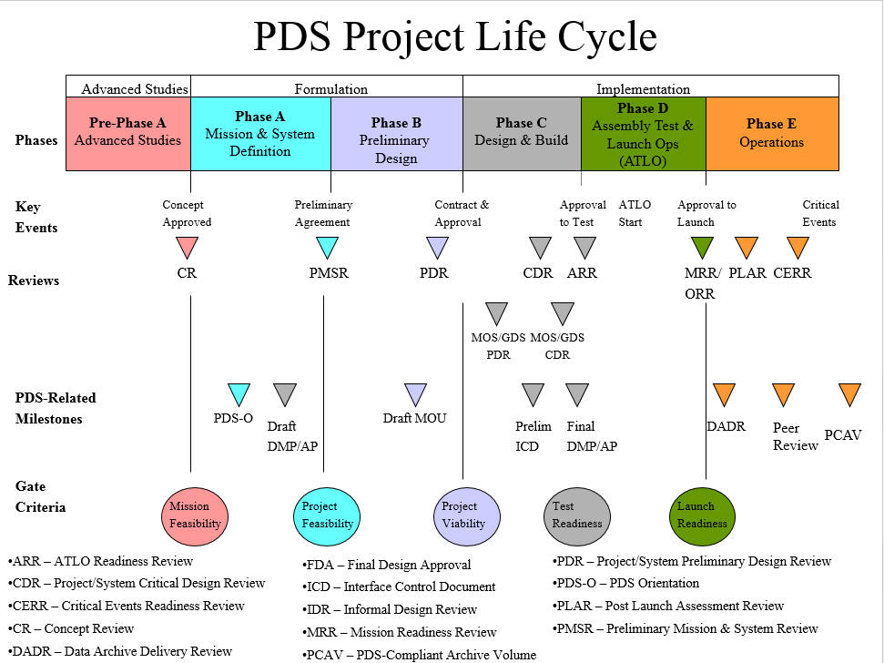

Figure 6-1. PDS Project Life Cycle

deliverables expected by the pds

The following deliverables (in addition to the data themselves) are expected by the PDS to establish coordination and communication channels, determine roles and responsibilities, and to define the scope of an archive; all may become components of the archive itself.

Memo of Understanding (MOU)

The MOU is a short document negotiated between a new mission and the PDS defining/delineating roles and mutual responsibilities regarding archiving and distribution of mission data. The MOU also contains a list of documents to be produced and the parties responsible for producing them. The MOU is produced early in KDP B. See the PAG web page for an example (http://pds.jpl.nasa.gov/pds4/propose/proposing.shtml).

Data Management and Archiving Plan (DMAP)

The DMAP is a general description of mission data processing, cataloging, and communications and a more detailed description of the generation, validation, and transfer (including schedule) of the mission archive to the PDS. The DMAP may be delivered as a single document or as separate Data Management Plan (DMP) and Archiving Plan (AP). Drafts of these are prepared during KDP B and finalized in KDP C. See the PAG web page for an example (http://pds.jpl.nasa.gov/pds4/propose/proposing.shtml).

Interface Control Document (ICD)

The ICD is a signed agreement between an instrument team and a PDS node. The ICD spells out each party’s responsibilities with regard to archive design and implementation. Each data delivery must be accompanied by the current, complete ICD for that delivery.

Archive Description Document (ADD)

The mission will prepare the ADD, which describes both the format and content of the archive which will be delivered — at the bit level, if needed. The ADD is a "fictitious" document in the sense that the term ADD represents the collection of interface specifications, reports, algorithm descriptions, etc. that were written for other purposes, but which have now been assembled and integrated to document the archive. The ADD does not have to exist as an identifiable document itself.

Context Products

The context collection is delivered on schedules given in the Archive Plan. Typically mission and spacecraft context descriptions are drafted and maintained by mission personnel working with the lead node, while instrument descriptions are drafted and maintained by the respective instrument teams working with the lead node. However, the steward for all context products is the PDS Engineering Node, so close coordination is required between the authors of these products and their EN counterparts. The information in these context products becomes part of the PDS4 registry.

Draft versions of context products are delivered during KDP C for purposes of distribution. Initial versions of context products must be delivered no later than early KDP E. The context products may be updated throughout the mission and the updated versions will be finalized at the end of the mission. See the PDS Standards Reference [1] for more information.

Lien Resolution

Resolutions to all problems identified during peer reviews are required before the PDS accepts archive bundles. See Section 6.8 for additional information on resolving peer review liens.

APPENDIX A ACRONYMS

The table below lists acronyms and abbreviations used in this document.

ADD | Archive Description Documentation
AO | Announcement of Opportunity
AP | Archive Plan
CDR | Critical Design Review
CSR | Concept Study Report
DMAP | Data Management and Archiving Plan
DMP | Data Management Plan
DN | Discipline Node
EN | Engineering Node
FTE | Full Time Employee or Full Time Equivalent
GDS | Ground Data System
ICD | Interface Control Document
ITAR | International Traffic in Arms Regulations
KDP | Key Decision Point
MRR | Mission Readiness Review
NAIF | Navigation and Ancillary Information
NASA | National Aeronautics and Space Administration
MOU | Memorandum of Understanding
NRA | NASA Research Announcement
NSSDCA | NASA Space Science Data Coordinated Archive
Ops | Operations
PAG | Proposer’s Archiving Guide
PDR | Preliminary Design Review
PDS | Planetary Data System
PI | Principal Investigator
SIS | Software Interface Specification
SPICE | Spacecraft ephemeris, Planet/satellite ephemeris, Instrument information, Camera orientation, Event information.
TBD | To be determined
URL | Uniform Resource Locator
USGS | United States Geological Survey
Table A-1. Acronyms and abbreviations

APPENDIX B ONLINE RESOURCES / REFERENCES

The following resources may be of interest during proposal preparation and are available electronically at either the designated URL or the Proposers Archiving Guide (PAG) web page:

http:// http://pds.jpl.nasa.gov/pds4/propose/proposing.shtml

- PDS Home Page (http://pds.nasa.gov)

- PDS4 Main Page (http://pds.jpl.nasa.gov/pds4/about/index.shtml)

- PDS4 Standards Reference -Specific PDS data preparation standards for archive quality data sets. (https://pds.nasa.gov/pds4/doc/sr/current/StdRef_1.4.0_150922.pdf)

- PDS4 Data Dictionary - List of PDS-recognized classes and attributes and acceptable values where restrictions apply. (https://pds.nasa.gov/pds4/doc/dd/current/PDS4_PDS_DD_1500.pdf)

- PDS4 Proposer’s Archiving Guide (PAG) (This document) (http://pds.jpl.nasa.gov/pds4/propose/pds4-pag.pdf)

- Example Documents, Context files, Products and Labels can be found on the Documentation web page (http://pds.jpl.nasa.gov/pds4/propose/proposing.shtml)

- Example Memorandum of Understanding (MOU)

- Example Data Management and Archiving Plan (DMAP)

PDS4 documents governing archive preparation (http://pds.nasa.gov/pds4/doc/)

Includes the Discovery 2014 / 2015 missions: - Psyche - NEOCam - Lucy - VERITAS - DAVINCI
“PDF/A” is a shorthand reference to “ISO 19005-1:2005— Document Management — Electronic document file format for long-term preservation – Part 1: Use of PDF 1.4 (PDF/A-1). “ This standard, based on Adobe’s Portable Document Format reference version 1.4, is designed for use in archival storage of documents. It builds on the underlying PDF standard by adding additional requirements to ensure that the document file itself contains sufficient information that it can be reproduced exactly from its contents.
PDS4 documents governing archive preparation are available online: http://pds.nasa.gov/pds4/doc/

